**7 THE BOULEVARD, CHELTENHAM**

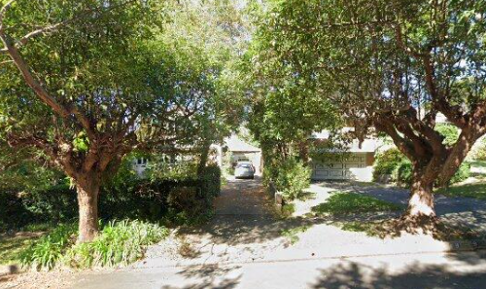

Lot A DP 308351

**Hornsby Shire Council details**

**Heritage Register: (NONE)**

Part of Mount Pleasant Estate – Cheltenham 1st Subdivision 1908

No. 7 The Boulevard was built circa 1925 and has had a number of additions. The first Cheltenham kindergarten was conducted in the then garage.

The first known occupants were Clifford Vernon Spier (clerk) and Ethel Florence Spier, in 1937.

*[Clifford Spier of Epping married Ethel (‘Essie’) Stubbin of Ryde in 1928]*

In 1958 Clifford and Ethel were still living at 7 The Boulevard, Cheltenham.

They later moved to Mt. Colah.

**Bibliography: none**

**Resources available (varies):**

* Sands Directories 1858-1933 City of Sydney [Sands Postal Directory | City of Sydney Archives (nsw.gov.au)](https://archives.cityofsydney.nsw.gov.au/nodes/view/495003)
* Newspaper articles – TROVE - [Search - Trove (nla.gov.au)](https://trove.nla.gov.au/search/advanced/category/newspapers)
* Ancestry.com (subscription only) [Genealogy, Family Trees and Family History Records online - Ancestry.com](https://www.ancestry.com.au/) – Sands Directories, Electoral Rolls, Family photos (Public Member photos), Census lists, marriage details, + miscellaneous
* N.S.W. Births, Deaths & Marriages [Family history search | NSW Government](https://www.nsw.gov.au/family-and-relationships/family-history-search) (QLD & Victoria also obtainable online)
* House photos and information via Hornsby Shire Council website for Property Search and Heritage Register [Heritage | Hornsby Shire Council (nsw.gov.au)](https://www.hornsby.nsw.gov.au/property/build/heritage)
* House photos and associated information via Internet search on address via Real Estate websites (from 2005)
* “Beecroft and Cheltenham Heritage Walks” - Beecroft-Cheltenham History Group Inc. 2004 book (1st edition)
* Australian War Museum website [Home | Australian War Memorial (awm.gov.au)](https://www.awm.gov.au/)