**72 CHELTENHAM ROAD, CHELTENHAM (“King’s Lynn”)**

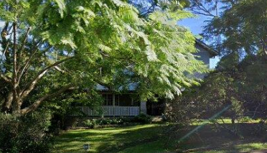

Lot 3 DP 565977

**Hornsby Shire Council details**

**Heritage Register: (NONE)**

Part of Wills Estate – Cheltenham Subdivision 1918

The house has had a second-storey added in more recent years, the ground floor little changed.

Sands Directories 1921-1932/33 Travers L. Brett “King’s Lynn”

Electoral Roll 1933: Travers Brett No. 72

In 1923 Travers L. Brett was living at “Kings Lynn, 72 Cheltenham-road, Cheltenham.

Prior to this, in 1913, Travers Longfield Brett was living with his parents, William Frederick Brett (civil servant) and his wife May Grace Brett, at “Bryntirion,” 48 Boronia-avenue, Cheltenham.

In 1916 Lieutenant Travers Longfield Brett, of the 4th Battalion, married Louise Estelle (‘Essie’) Mutton, of Roseville, at St. Philip’s, Church Hill, Sydney.

*[Travers L. Brett was born in 1892, at Watsons Bay; Essie was born in 1893 at Rockdale]*

Lieutenant Travers Brett, 22nd Bn, adjutant, left the UK in April 1920.

A son, Oswald Longfield, was born at “Bryntirion” in 1921. A daughter, Estelle Judith, was born in 1923.

In December 1926, at Echallens College (60 Cheltenham-road, Cheltenham) Oswald Brett would receive prizes in writing and geography.

By 1933 Travers’ occupation was ‘manager.’

In 1935 Grace Longfield Brett, aged 36 years, the sister of Travers, would die of septicaemia from a rose thorn having punctured her finger.

In 1936 Oswald received an award for painting.

In 1938 he was a pupil of the well-known marine artist, Mr. John Allcot, and, aged 16 years, painted these ships.

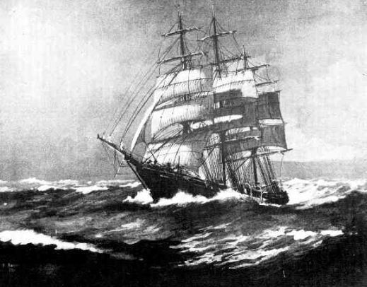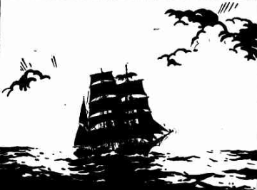

‘He also drew inspiration for painting from his mother Estelle Brett (née Mutton), a talented amateur portrait and landscape artist. Both Estelle and Oswald’s sister Judith encouraged him with his painting even later in his life. Os, as he was affectionately called by his friends, knew at an early age that he would be a professional artist concentrating entirely on ships and the sea.’

In 1938, Estelle Judith, daughter of Travers Brett, was hospitalized, crippled by infantile paralysis, affecting her legs and back, but still won prizes for painting and needlework.

Travers Brett would enlist for the 2nd World War, service no. N74559, A.C.M.F.

In 1944 Oswald Brett would marry in New York U.S.A., Gertrude Elizabeth Steacy. He would become a world-renowned marine artist. He died in 2017, aged 96 years, after a fall in his home on Long Island, New York.

In 1945 Judith Elizabeth Brett would become engaged to Arthur John Frizelle (A.I.F. ret.), of Balgowlah. They would eventually marry.

In 1962 Travers Longfield Brett died in Chile, South America.

In 1972 Louise was still living at 72 Cheltenham-road. By 1980 she had moved to Roseville, and died in 1981.

**Bibliography: none**

**Resources available (varies):**

* Sands Directories 1858-1933 City of Sydney [Sands Postal Directory | City of Sydney Archives (nsw.gov.au)](https://archives.cityofsydney.nsw.gov.au/nodes/view/495003)
* Newspaper articles – TROVE - [Search - Trove (nla.gov.au)](https://trove.nla.gov.au/search/advanced/category/newspapers)
* Ancestry.com (subscription only) [Genealogy, Family Trees and Family History Records online - Ancestry.com](https://www.ancestry.com.au/) – Sands Directories, Electoral Rolls, Family photos (Public Member photos), Census lists, marriage details, + miscellaneous
* N.S.W. Births, Deaths & Marriages [Family history search | NSW Government](https://www.nsw.gov.au/family-and-relationships/family-history-search) (QLD & Victoria also obtainable online)
* House photos and information via Hornsby Shire Council website for Property Search and Heritage Register [Heritage | Hornsby Shire Council (nsw.gov.au)](https://www.hornsby.nsw.gov.au/property/build/heritage)
* House photos and associated information via Internet search on address via Real Estate websites (from 2005)
* “Beecroft and Cheltenham Heritage Walks” - Beecroft-Cheltenham History Group Inc. 2004 book (1st edition)
* Australian War Museum website [Home | Australian War Memorial (awm.gov.au)](https://www.awm.gov.au/)