**73 CHELTENHAM ROAD, CHELTENHAM (“Shaugh”)**

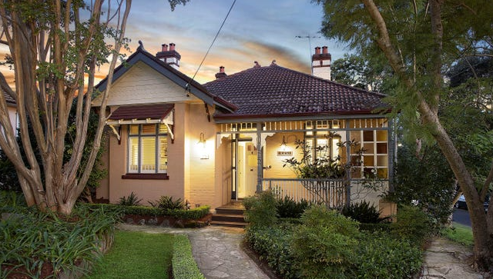

73 Cheltenham Road Lot 1 DP 902631

51 Boronia Avenue Lot 1 DP 902631

**Hornsby Shire Council details**

**Heritage Register: (NONE)**

Part of Beecroft & Cheltenham – Land for Sale Subdivision 1906

In 1913 the house was occupied by Robert McKay (clerk) and Ruby Ethel McKay.

*[Robert McKay married Ruby E. Donald in 1909, in the district of Marrickville]*

Sands Directories 1915-1924 Robert McKay; 1925-27 Harry S. Gulliford; 1930-1932/33 Syd. S. Merrifield, med. pract.

Electoral Roll 1933: Sydney Merrifield No. 73

By 1925 the house was occupied by Harry S. Guilford, and by 1930 by Sydney Sargent Merrifield, medical practitioner,

In 1933 Dr. Merrifield was still in residence, along with Sarah Elizabeth Merrifield, at 73 Cheltenham-road, Cheltenham.

In 1935 Dr. Sydney Sargent Merrifield, M.R.C.S., Eng., L.S.A., A.K.C., died at Cheltenham, aged 73 years.

‘He was a native of Devonshire, England. He completed his medical training at King's College, London. Coming to New South Wales, he practised for 25 years at Bundarra, and subsequently moved to Bellingen. He retired about five years ago, and went to live at Cheltenham. He is survived by Mrs. Merrifield, two daughters, and one son.’

By 1937 the home had been let to William Allen Jackson (concrete hand) and Irene Adelaide Jackson.

In 1945 “Shaugh” was put up for auction, described as follows:  
‘By Order of THE PUBLIC TRUSTEE. Re Estate of S. S. Merrifield, deed

"SHAUGH. " No. 73 CHELTENHAM ROAD, CHELTENHAM (cr. Boronia Avenue).

D.F. BRICK COTTAGE, with tiled roof and front ver., containing 4 rooms, kit. and Iaun. combined, bathroom with gas heater. ver. room enc. rear ver., pantry, tool-shed, workshop, fibro garage. Land 60 x 198. Let at 30/- per wk.’**1**

The Jacksons would still be living there in 1977 so presumably they purchased the property. William Allen Jackson died in 1978.

Their son, Geoffrey, would be registered as a doctor in 1957.

The house was last sold in 2020.**2**

**Bibliography:**

1 Sydney Morning Herald, 10th February 1945

2 [73 Cheltenham Road, Cheltenham, NSW 2119 - Property Details (realestate.com.au)](https://www.realestate.com.au/sold/property-house-nsw-cheltenham-133212130)

**Resources available (varies):**

* Sands Directories 1858-1933 City of Sydney [Sands Postal Directory | City of Sydney Archives (nsw.gov.au)](https://archives.cityofsydney.nsw.gov.au/nodes/view/495003)
* Newspaper articles – TROVE - [Search - Trove (nla.gov.au)](https://trove.nla.gov.au/search/advanced/category/newspapers)
* Ancestry.com (subscription only) [Genealogy, Family Trees and Family History Records online - Ancestry.com](https://www.ancestry.com.au/) – Sands Directories, Electoral Rolls, Family photos (Public Member photos), Census lists, marriage details, + miscellaneous
* N.S.W. Births, Deaths & Marriages [Family history search | NSW Government](https://www.nsw.gov.au/family-and-relationships/family-history-search) (QLD & Victoria also obtainable online)
* House photos and information via Hornsby Shire Council website for Property Search and Heritage Register [Heritage | Hornsby Shire Council (nsw.gov.au)](https://www.hornsby.nsw.gov.au/property/build/heritage)
* House photos and associated information via Internet search on address via Real Estate websites (from 2005)
* “Beecroft and Cheltenham Heritage Walks” - Beecroft-Cheltenham History Group Inc. 2004 book (1st edition)
* Australian War Museum website [Home | Australian War Memorial (awm.gov.au)](https://www.awm.gov.au/)