**76 THE CRESCENT, CHELTENHAM**

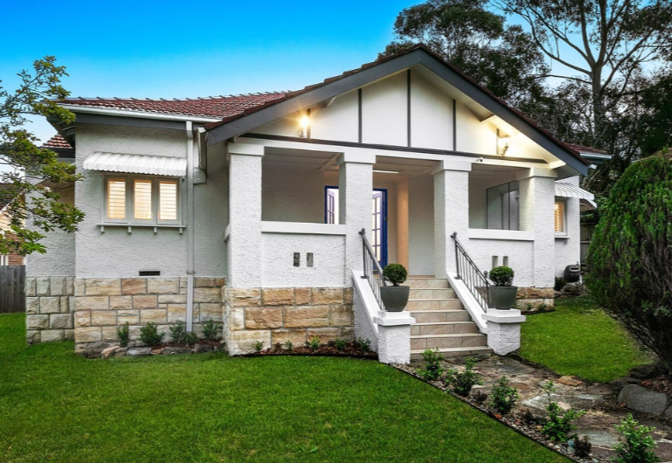

76 The Crescent Lot 9 DP 7811

1A Lyne Road Lot 9 DP 7811

**Hornsby Shire Council details**

**Heritage Register: (NONE)**

In 1922 the house was put up for sale, described as follows:

CHELTENHAM. – New Brick Bungalow, on stone foundation, tile roof, 6 rooms, kitchen, etc., bathroom tiled, all latest appointments, Land,79ft 3in x 200ft. Corner Lyne-st. and Cheltenham-crescent, 3 mins. From station.

D. SHANKS, builder, Beecroft. Epping 531.1

Sands Directories 1926-1932/3 David Shanks, builder, “Pentlands”

Electoral Roll 1933: David Shanks No. 76

It appears to have been a rental property over many years:

1933 - David Harper (carpenter), Mary Ann Scott Harper, David Harper (carpenter)

1937 - Frank Hundt (teacher), Isabella Hundt (home duties), Cecelia Rose Pike (teacher)

1943 - Brian Berkeley McFarlane (machinist), Lily Edith McFarlane

The house was last sold in 2023 (prev. 2017).2

**Bibliography:**

1 Sydney Morning Herald, 2nd September 1922.

2 [76 The Crescent, Cheltenham, NSW 2119 - House for Sale - realestate.com.au](https://www.realestate.com.au/property-house-nsw-cheltenham-142977612)

**Resources available (varies):**

* Sands Directories 1858-1933 City of Sydney [Sands Postal Directory | City of Sydney Archives (nsw.gov.au)](https://archives.cityofsydney.nsw.gov.au/nodes/view/495003)
* Newspaper articles – TROVE - [Search - Trove (nla.gov.au)](https://trove.nla.gov.au/search/advanced/category/newspapers)
* Ancestry.com (subscription only) [Genealogy, Family Trees and Family History Records online - Ancestry.com](https://www.ancestry.com.au/) – Sands Directories, Electoral Rolls, Family photos (Public Member photos), Census lists, marriage details, + miscellaneous
* N.S.W. Births, Deaths & Marriages [Family history search | NSW Government](https://www.nsw.gov.au/family-and-relationships/family-history-search) (QLD & Victoria also obtainable online)
* House photos and information via Hornsby Shire Council website for Property Search and Heritage Register [Heritage | Hornsby Shire Council (nsw.gov.au)](https://www.hornsby.nsw.gov.au/property/build/heritage)
* House photos and associated information via Internet search on address via Real Estate websites (from 2005)
* “Beecroft and Cheltenham Heritage Walks” - Beecroft-Cheltenham History Group Inc. 2004 book (1st edition)
* Australian War Museum website [Home | Australian War Memorial (awm.gov.au)](https://www.awm.gov.au/)