**78 THE CRESCENT, CHELTENHAM (“Argyle”)**

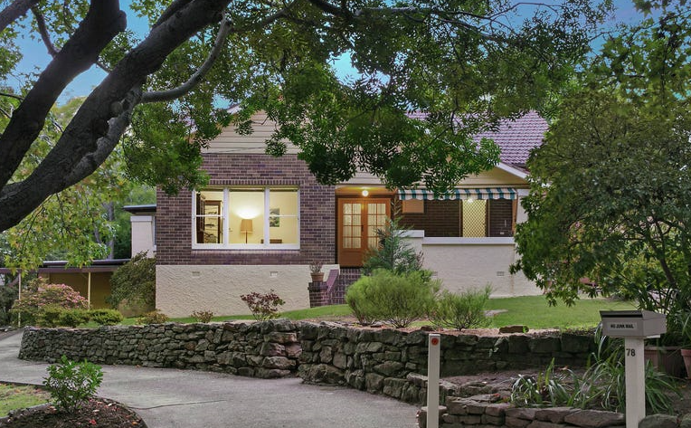

Lot 10 DP 7811

**Hornsby Shire Council details**

**Heritage Register: (NONE)**

Both 78 & 80 were designed by James Vicars the architect relative of Robert & Violet Vicars of *Yallambee,* The Promenade. When built these houses had matching fronts including double front doors centring a full-length front verandah.

*No. 78 is said to have been owned by James Malcolm Kither (‘Malcolm’) Vicars, the son of James Vicars, the designer. He married Doris E. Rowe in 1923 and spent a few years in The Crescent before moving to Queensland in 1930 or 1931. A son was born in Cheltenham in 1925.*

In 1912 Arthur William Munro, late of Forest Lodge, was living in “Argyle,” Beecroft-road, Cheltenham.

In 1918 His wife, Mary Ann, died, aged 71 years, at her daughter’s residence in Hornsby. Children were William, Edward (on active service), Arthur R., and Mildred Munro.

Arthur R. Munro, son of Arthur W. Munro, was living at Beecroft-road (West side) up to 1923. By 1924 Arthur R. Munro had moved to 78 The Crescent, Cheltenham, again named “Argyle.”

Sands Directories 1924-1932/3 Arthur W. Munro “Argyle” Beecroft-road

Electoral Roll 1933: Arthur Munro No. 80 (Arthur R.)

Sands Directories 1924-31 Malcolm Vicars

In 1926 Arthur William Munro died, aged 73 years, at his son’s residence, “Argyle,” The Crescent (then called Cheltenham-crescent).

By 1933 The Munro family had moved next door, no. 80 The Crescent, Cheltenham,

In 1933, Edgar Charles Bond occupied 78 The Crescent. His wife, Florence Rachel, of this address, formerly of Goulburn, died that year at this address, aged 55 years.

*[Edgar Charles Bond married Florence Rachel Walker in 1926, in Mosman]*

*They had resided the previous year at “Lyndhurst,” Cheltenham-road, Cheltenham.*

In 1935 the house was put up for sale, described as follows:

CHELTENHAM

No 78 CHELTENHAM CRESCENT

Facing the Railway Line next to corner of Lyne-rd.

DETACHED BRICK COTTAGE, tiled roof, Front Verandah Hall, Lounge and Dining Room, 2 Bedrooms (one with built-in press), Bathroom, Linen Press, Kitchen, Pantry, Laundry, Verandah at side and rear.

Gravel Path, Lawns Garden, and Fernery. Let at 30/- per week.

LAND about 79 feet 3 Inches by 173 feet 10 ¾ Inches and 153 feet 2 inches with 69 feet 11 Inches at rear.1

In 1937 the house was again put up for sale, described as follows:

CHELTENHAM,

"ARGYLE " CHELTENHAM CRESCENT, NEAR LYNE ROAD

A faithfully built cottage on brick foundations with tile roof. CONTAINS 3 BEDROOMS, 3

RECEPTION-ROOMS, large kitchen and pantry, tiled bathroom, SPACIOUS SLEEP-OUT VERANDAH AT SIDE, onto which all bedrooms open. Also rear verandah. Garage. LAND 79ft x 140ft/150ft PLUS AN ADDITIONAL BLOCK TO LYNE ROAD, 66ft x 200ft.2

[The additional block would be No. 1 Lyne-road, behind Nos. 76, 78 & 80 The Crescent]

In 1943 the home was occupied by William Henry Medicott Andrews (accountant), Mavis Martha Andrews and Isabel Stibbard (home duties)

The house was last sold in 2021.3

[999.1 sqm block. 79ft = 24m; 140ft = 42.6m; 24 x 42.4 = 1017 sqm]

It is said to have been occupied by the same family for over 65 years. [since circa 1956]

**Bibliography:**

1 Sydney Morning Herald, 27th April 1935

2 Sydney Morning Herald, 3rd November 1937

3 [78 The Crescent, Cheltenham, NSW 2119 - Property Details (realestate.com.au)](https://www.realestate.com.au/sold/property-house-nsw-cheltenham-136084518)

**Resources available (varies):**

* Sands Directories 1858-1933 City of Sydney [Sands Postal Directory | City of Sydney Archives (nsw.gov.au)](https://archives.cityofsydney.nsw.gov.au/nodes/view/495003)
* Newspaper articles – TROVE - [Search - Trove (nla.gov.au)](https://trove.nla.gov.au/search/advanced/category/newspapers)
* Ancestry.com (subscription only) [Genealogy, Family Trees and Family History Records online - Ancestry.com](https://www.ancestry.com.au/) – Sands Directories, Electoral Rolls, Family photos (Public Member photos), Census lists, marriage details, + miscellaneous
* N.S.W. Births, Deaths & Marriages [Family history search | NSW Government](https://www.nsw.gov.au/family-and-relationships/family-history-search) (QLD & Victoria also obtainable online)
* House photos and information via Hornsby Shire Council website for Property Search and Heritage Register [Heritage | Hornsby Shire Council (nsw.gov.au)](https://www.hornsby.nsw.gov.au/property/build/heritage)
* House photos and associated information via Internet search on address via Real Estate websites (from 2005)
* “Beecroft and Cheltenham Heritage Walks” - Beecroft-Cheltenham History Group Inc. 2004 book (1st edition)
* Australian War Museum website [Home | Australian War Memorial (awm.gov.au)](https://www.awm.gov.au/)
* Beecroft and Cheltenham History Group website [Beecroft and Cheltenham History - Beecroft Cheltenham History Group (bchg.org.au)](https://bchg.org.au/)