**8 CHELTENHAM ROAD, CHELTENHAM**

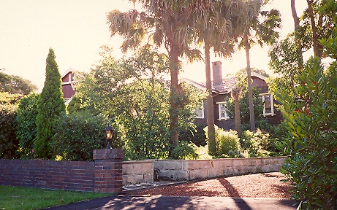

Lots 138 & 139 DP 12364

**Hornsby Shire Council details**

**Heritage Register: Item No. 271**

Part of Mount Pleasant Estate – Cheltenham 3rd Subdivision 1924

Large Inter-War Bungalow style single-storey brick house, which forms a pair with No. 8 adjoining.

*NOTE: Perhaps No. 8 and No. 10 were built as two residences at the same time to accommodate separately the various members of the Whitney family, with the postal address as No. 10 up to the time that it was sold, or leased, to the Joyce family about 1940, then two separate addresses were used.*

Sands Directories 1927-1932/3 A. H. Whitney

Electoral Roll 1933: Athelstone Whitney No. 10

Built c.1925 for Athelstane Hubert Whitney, solicitor.

*[Athelstane and his two unmarried sisters were previously living at No.10 Cheltenham-road, Cheltenham.]*

The 1943 Electoral Roll lists Athelstone Hubert Whitney (solicitor), Beatrice Eleanor Whitney and Elizabeth Martha ‘Lily’ Whitney as living at 8 Cheltenham-road, Cheltenham

In 1944 Athelstane died at his Cheltenham residence, and in 1953 Elizabeth Martha (‘Lily’) Whitney also died there.

**Bibliography: none**

**Resources available (varies):**

* Sands Directories 1858-1933 City of Sydney [Sands Postal Directory | City of Sydney Archives (nsw.gov.au)](https://archives.cityofsydney.nsw.gov.au/nodes/view/495003)
* Newspaper articles – TROVE - [Search - Trove (nla.gov.au)](https://trove.nla.gov.au/search/advanced/category/newspapers)
* Ancestry.com (subscription only) [Genealogy, Family Trees and Family History Records online - Ancestry.com](https://www.ancestry.com.au/) – Sands Directories, Electoral Rolls, Family photos (Public Member photos), Census lists, marriage details, + miscellaneous
* N.S.W. Births, Deaths & Marriages [Family history search | NSW Government](https://www.nsw.gov.au/family-and-relationships/family-history-search) (QLD & Victoria also obtainable online)
* House photos and information via Hornsby Shire Council website for Property Search and Heritage Register [Heritage | Hornsby Shire Council (nsw.gov.au)](https://www.hornsby.nsw.gov.au/property/build/heritage)
* House photos and associated information via Internet search on address via Real Estate websites (from 2005)
* “Beecroft and Cheltenham Heritage Walks” - Beecroft-Cheltenham History Group Inc. 2004 book (1st edition)
* Australian War Museum website [Home | Australian War Memorial (awm.gov.au)](https://www.awm.gov.au/)