**8 OLD BEECROFT ROAD, CHELTENHAM (Belmore Cottage)**

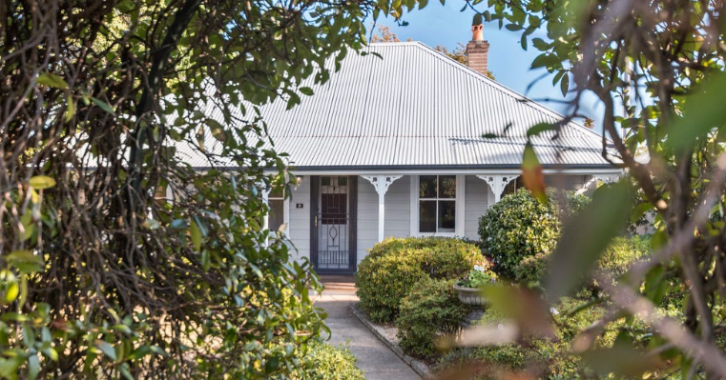

Lot A DP 418135

**Hornsby Shire Council details**

**Heritage Register: (NONE)**

James Arthur Kingcott & family were living at Beecroft-road, Cheltenham in 1899. This house is assumed to be his residence.

*[James A. Kingcott married Martha Bennett at St Stephen’s Church, Newtown in 1891]*

*James was one of 7 children of Alfred Henry Kingcott (fruit-grower), died 1905, and his wife Charlotte, died 1903, of Epping.*

In January 1900 his home along Beecroft-road, Cheltenham, was burgled. His occupation was then a painter, which he would continue to do throughout his lifetime, The three teenage thieves were apprehended and given 6 months’ hard labour at Darlinghurst Goal.

The Census of 1901 records the household of James A. Kingcott as being occupied by4 males and 2 females living at the property.

The household would have consisted of James; his three sons: James A. H., Arthur G., and Francis C. (born Ryde district 1899 - died 1906); a daughter Florence, and James’ wife Martha.

Three other children were born later – William A., Martha D., and Annie E., all born Ryde district (presumably Cheltenham).

**Flo, James, Martha, Alf, Annie, Martha Daphne, Arthur & William**

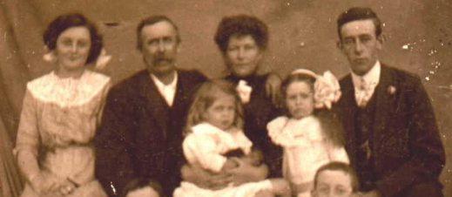

In 1909 Mrs. J. Kingcott wrote to Hornsby Shire Council asking them ‘to keep the main road from Beecroft to Cheltenham in repair, as it was in a dreadful state, and impassable even for the tradespeople, and she did not see why she should pay Shire rates for nothing. It was pointed out that this was the old road, not now used for general traffic.’

In 1913 James Kingcott, of Beecroft-road, Cheltenham, advertised a milking cow, in calf, for sale, so the land must have been of a reasonable size.

Sands Directories 1915-1927: James A. Kingcott “Belmore Cottage” Beecroft-road West just before deviation road (Old Beecroft-road)

**Sands Directories 1931-1932/3: J. A. Kilcott (sic), “Marthaville”**

In 1915 & 1917 James A. Kingcott is recorded as living at “Belmore Cottage,” Beecroft-road, Cheltenham.

In 1917 James A. Kingcott, painter, purchased 3 roods 19.5 perches (just under 1 acre) of Portion 865 of Field of Mars Parish, for £50. Also, that year he was calling for tenders for breaking, ploughing and harrowing 1 ½ acres of orchard.

In the Electoral Rolls for 1930 & 1932 James is living at “Belmore,” not “Belmore Cottage.”

However, between 1930 and 1932 James is also recorded as living at “Marthaville.” This may have been the name of the property, not the house.

Between 1933 and 1949 James’s address was 16 Old Beecroft-road, Cheltenham, however when he died in 1951 at his residence, the address is 8 Old Beecroft-road, Cheltenham.

His wife Martha died in 1959, aged 89 years.

**James Arthur Kingcott (1869 – 1951)**

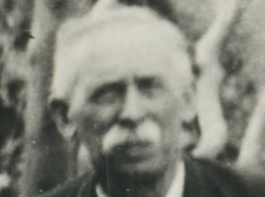

In 1963 Mark Anthony Kingcott (grandson of James A. Kingcott), of 8 Old Beecroft-road, Cheltenham, received an appointment in the Department of the Attorney-General and of Justice.

The house was last put up for sale in 2018, but no history is available.

**Bibliography: none**

**Resources available (varies):**

* Sands Directories 1858-1933 City of Sydney [Sands Postal Directory | City of Sydney Archives (nsw.gov.au)](https://archives.cityofsydney.nsw.gov.au/nodes/view/495003)
* Newspaper articles – TROVE - [Search - Trove (nla.gov.au)](https://trove.nla.gov.au/search/advanced/category/newspapers)
* Ancestry.com (subscription only) [Genealogy, Family Trees and Family History Records online - Ancestry.com](https://www.ancestry.com.au/) – Sands Directories, Electoral Rolls, Family photos (Public Member photos), Census lists, marriage details, + miscellaneous
* N.S.W. Births, Deaths & Marriages [Family history search | NSW Government](https://www.nsw.gov.au/family-and-relationships/family-history-search) (QLD & Victoria also obtainable online)
* House photos and information via Hornsby Shire Council website for Property Search and Heritage Register [Heritage | Hornsby Shire Council (nsw.gov.au)](https://www.hornsby.nsw.gov.au/property/build/heritage)
* House photos and associated information via Internet search on address via Real Estate websites (from 2005)
* “Beecroft and Cheltenham Heritage Walks” - Beecroft-Cheltenham History Group Inc. 2004 book (1st edition)
* Australian War Museum website [Home | Australian War Memorial (awm.gov.au)](https://www.awm.gov.au/)