**80 THE CRESCENT, CHELTENHAM (“Pentlands”)**

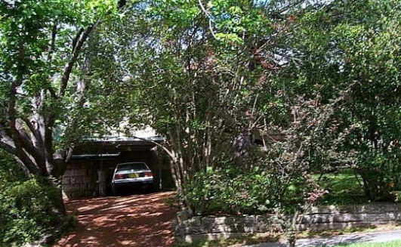

Lot 11 DP 7811

**Hornsby Shire Council details**

**Heritage Register: (NONE)**

Both 78 & 80 were designed by James Vicars the architect relative of Robert & Violet Vicars of *Yallambee,* The Promenade. When built these houses had matching fronts including double front doors centring a full-length front verandah. 80 has been altered by having a front room added on the southern side with consequential change to the roof line and gable. The extent to which the houses are stuccoed also differs.

Sands Directories 1921-1923 Dudley J. Price; 1925-1932/33 Arthur W. Munro “Argyle”

Electoral Roll 1933: Arthur Munro No. 84

Sands Directories 1926-1932/3 David Shanks, builder, “Pentlands”

Electoral Roll 1933: David Shanks No. 76

Sands Directories

In 1927 David Shanks, builder, was living at “Pentlands,” The Crescent (then named Cheltenham-crescent), Cheltenham

In 1932 the home was occupied by David Harper Shanks (carpenter), Mary Ann Scott Harper and David Harper Shanks [junior], carpenter.

In 1933 Arthur Robert Munro (brass-founder) and wife Harriet Maude Munro occupied 80 Cheltenham-crescent, Cheltenham.

In 1936 Harriet Maude Munro of this address died.

In 1937 occupants were Arthur Robert Munro (brass-founder) and Harold William Leslie Pryor (bootmaker)

In 1938 Arthur Robert Munro married Amy Florence Garrad, at Milton.

In 1943 Arthur Robert Munro (brass-founder), Amy Florence Munro and Ronald Arthur Ernest Munro (brass-founder) were in residence.

Arthur Robert Munro died in 1951 at his residence, 80 The Crescent, Cheltenham, aged 66 years.

**Bibliography: none**

**Resources available (varies):**

* Sands Directories 1858-1933 City of Sydney [Sands Postal Directory | City of Sydney Archives (nsw.gov.au)](https://archives.cityofsydney.nsw.gov.au/nodes/view/495003)
* Newspaper articles – TROVE - [Search - Trove (nla.gov.au)](https://trove.nla.gov.au/search/advanced/category/newspapers)
* Ancestry.com (subscription only) [Genealogy, Family Trees and Family History Records online - Ancestry.com](https://www.ancestry.com.au/) – Sands Directories, Electoral Rolls, Family photos (Public Member photos), Census lists, marriage details, + miscellaneous
* N.S.W. Births, Deaths & Marriages [Family history search | NSW Government](https://www.nsw.gov.au/family-and-relationships/family-history-search) (QLD & Victoria also obtainable online)
* House photos and information via Hornsby Shire Council website for Property Search and Heritage Register [Heritage | Hornsby Shire Council (nsw.gov.au)](https://www.hornsby.nsw.gov.au/property/build/heritage)
* House photos and associated information via Internet search on address via Real Estate websites (from 2005)
* “Beecroft and Cheltenham Heritage Walks” - Beecroft-Cheltenham History Group Inc. 2004 book (1st edition)
* Australian War Museum website [Home | Australian War Memorial (awm.gov.au)](https://www.awm.gov.au/)
* Beecroft and Cheltenham History Group website [Beecroft and Cheltenham History - Beecroft Cheltenham History Group (bchg.org.au)](https://bchg.org.au/)