**84 THE CRESCENT, CHELTENHAM (“Gareloch”)**

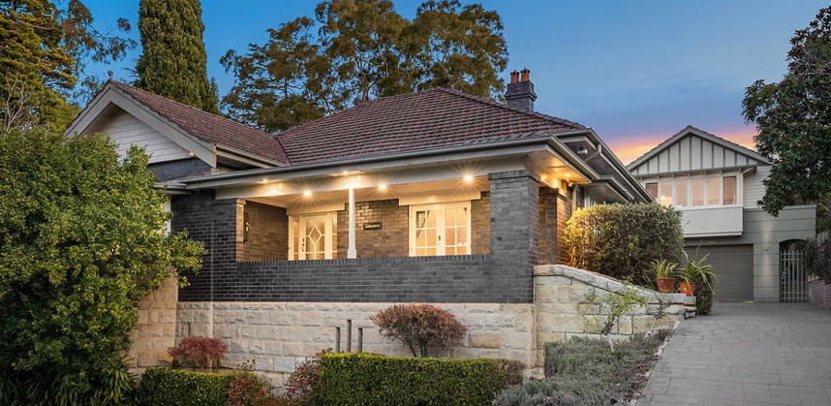

Lot 13A DP 317507

**Hornsby Shire Council details**

**Heritage Register: (NONE)**

*Gareloch* was built with Thornleigh bricks on a stone base. It has had a large extension at the rear in a manner sympathetic to retaining the importance of the streetscape.

In 1929 David Young advertised land for sale (79x220ft) in Cheltenham c/- “Gareloch.”

*[In 1915 David Young was a plumber, living at “Retreat,” (121 Beecroft-road, Beecroft)]*

Sands Directories 1930-32/33 D. Young “Gareloch”

Electoral Roll 1933: David Young No. 84

The 1933 Electoral Roll lists at this address David Young (builder), Catherine White Young and William Stonehill McAuley (tel. mech)

*[David Young married Catherine W. Duff in 1912, district of Petersham]*

That year he advertised land for sale at Cheltenham, fenced, 3 minutes from station.

In 1936 occurred the death of Anne Duff, at Eastwood, mother and grandmother of Mr. and Mrs. David Young, of 84 Cheltenham-crescent, Cheltenham, Mr. and Mrs. Daniel Duff and Family, of “Retreat,” Beecroft-road, Beecroft, and Mr. and Mrs. George Whittle and Family.

In 1937 occupants of the house were David Young (builder), Catherine White Young, Robert Gartner Brown (manager), Charles Francis Peck (clerk) and Reginald Gordon Smith (salesman).

By 1943 the house was occupied by David Stuart (accountant) and Enid Hanlie Stuart

In 1950 “Gareloch” was put up for sale, described as follows:

*BUILT OF BRICK, Solid Stone Foundation. Tile Roof. Wide front verandah, entrance at side, reception hall, cross hall, lounge, dining-room, 3 bedrooms, tiled bathroom, pedestal basin, separate shower recess, tiled kitchen, electric and gas stoves, sink and draining board, sink heater, servers' and pantry combined, Linen press, cupboards, built-in wardrobes. Laundry, outside toilet, septic sewerage. Brick garage and workshop. Ample storage space under front elevation.* *THE LAND, having a frontage of 79ft 3in by a depth of 220ft, is attractively laid out in gardens, lawns, paths, and fernery. TORRENS TITLE.*1

The house was last sold in 2023.2

**Bibliography:**

1 Sydney Morning Herald, 29th March 1950

2 <https://www.realestate.com.au/property/84-the-crescent-cheltenham-nsw-2119/>

**Resources available (varies):**

* Sands Directories 1858-1933 City of Sydney [Sands Postal Directory | City of Sydney Archives (nsw.gov.au)](https://archives.cityofsydney.nsw.gov.au/nodes/view/495003)
* Newspaper articles – TROVE - [Search - Trove (nla.gov.au)](https://trove.nla.gov.au/search/advanced/category/newspapers)
* Ancestry.com (subscription only) [Genealogy, Family Trees and Family History Records online - Ancestry.com](https://www.ancestry.com.au/) – Sands Directories, Electoral Rolls, Family photos (Public Member photos), Census lists, marriage details, + miscellaneous
* N.S.W. Births, Deaths & Marriages [Family history search | NSW Government](https://www.nsw.gov.au/family-and-relationships/family-history-search) (QLD & Victoria also obtainable online)
* House photos and information via Hornsby Shire Council website for Property Search and Heritage Register [Heritage | Hornsby Shire Council (nsw.gov.au)](https://www.hornsby.nsw.gov.au/property/build/heritage)
* House photos and associated information via Internet search on address via Real Estate websites (from 2005)
* “Beecroft and Cheltenham Heritage Walks” - Beecroft-Cheltenham History Group Inc. 2004 book (1st edition)
* Australian War Museum website [Home | Australian War Memorial (awm.gov.au)](https://www.awm.gov.au/)