**88 THE CRESCENT, CHELTENHAM**

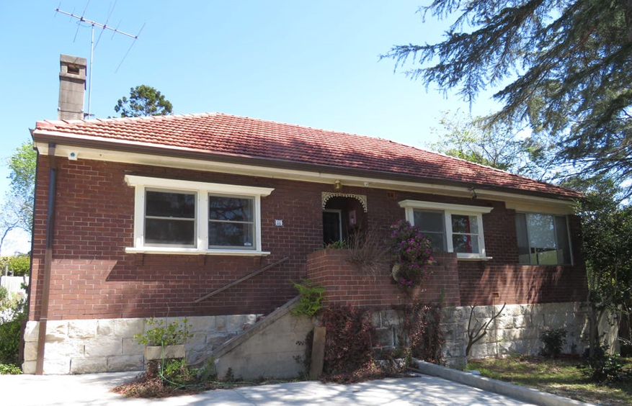

Lot 21 DP 1200140

**Hornsby Shire Council details**

**Heritage Register: (NONE)**

In 1933 occupants were James Mitchell Hicks (orchardist), Mary Ellen Hicks and Gordon James Hicks (radio eng.). They had just moved there from Carlingford.

Gordon Hicks married Mary Caldwell in 1934.

By 1935 his parents, James and Mary, had moved to Eastwood.

In 1954 Gordon was still living at this address.

**Bibliography: none**

**Resources available (varies):**

* Sands Directories 1858-1933 City of Sydney [Sands Postal Directory | City of Sydney Archives (nsw.gov.au)](https://archives.cityofsydney.nsw.gov.au/nodes/view/495003)
* Newspaper articles – TROVE - [Search - Trove (nla.gov.au)](https://trove.nla.gov.au/search/advanced/category/newspapers)
* Ancestry.com (subscription only) [Genealogy, Family Trees and Family History Records online - Ancestry.com](https://www.ancestry.com.au/) – Sands Directories, Electoral Rolls, Family photos (Public Member photos), Census lists, marriage details, + miscellaneous
* N.S.W. Births, Deaths & Marriages [Family history search | NSW Government](https://www.nsw.gov.au/family-and-relationships/family-history-search) (QLD & Victoria also obtainable online)
* House photos and information via Hornsby Shire Council website for Property Search and Heritage Register [Heritage | Hornsby Shire Council (nsw.gov.au)](https://www.hornsby.nsw.gov.au/property/build/heritage)
* House photos and associated information via Internet search on address via Real Estate websites (from 2005)
* “Beecroft and Cheltenham Heritage Walks” - Beecroft-Cheltenham History Group Inc. 2004 book (1st edition)
* Australian War Museum website [Home | Australian War Memorial (awm.gov.au)](https://www.awm.gov.au/)