**92 THE CRESCENT, CHELTENHAM (“Gunyah)**

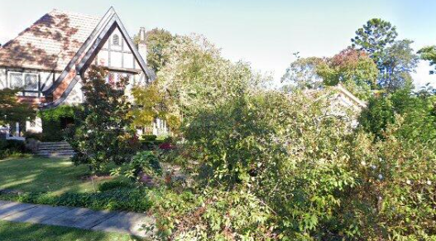

Lot 4 DP 9207 & Lot A DP 101306

**Hornsby Shire Council details**

**Heritage Register: (NONE)**

In August 1918 Hornsby Council approved the plans for a 4-roomed brick cottage in Cheltenham-crescent for Wm. John Price.

Sands Directories 1921-1923 Dudley J. Price; 1925-32/33 William J. Price “Gunyah”

Electoral Roll 1933: William Price No. 92

In 1923 William John Price living at “Gunyah.”

*[William J. Price, of Arncliffe, married Clarice List, of Dulwich Hill, in 1914, district of Canterbury]*

In 1927, at “Gunyah,” a daughter, Helen Jean Price, was born.

The 1933 Electoral Roll lists William John Price (contractor) and Clarice Price at 92 Cheltenham-avenue, Cheltenham.

In 1940 Joan, eldest daughter of Mr. & Mrs. W. J. Price, of Cheltenham, was engaged to Howard John, elder son of Mr. and Mrs. J. E. Gollan, of Cheltenham.

The 1943 Electoral Roll lists William John Price (contractor), Clarice Price, Dorothea Claire Price (typist) and Norma May Price (photographic assistant) at 92 Cheltenham-avenue, Cheltenham.

In 1949 Clarice, wife of William John Price, of Cheltenham, died.

In 1950 Helen Jean Price, of Cheltenham, was engaged to Kenneth James, eldest son of Mr. and Mrs. R. R. Cooper, of Alstonville.

In 1954 Norma Price, of Cheltenham, was engaged to Allen, only son of Mrs. J. Telfer and the late Mr. J. R. Telfer of Northmead.

The 1963 Electoral Roll lists William John Price (contractor), Helen Jean Price (nurse) and Lola Marjorie Price (solicitor) at 92 The Crescent, Cheltenham

William John Price died in 1964, aged 87 years. His residence at the time was 20 Elbon-avenue, Epping.

**Bibliography: none**

**Resources available (varies):**

* Sands Directories 1858-1933 City of Sydney [Sands Postal Directory | City of Sydney Archives (nsw.gov.au)](https://archives.cityofsydney.nsw.gov.au/nodes/view/495003)
* Newspaper articles – TROVE - [Search - Trove (nla.gov.au)](https://trove.nla.gov.au/search/advanced/category/newspapers)
* Ancestry.com (subscription only) [Genealogy, Family Trees and Family History Records online - Ancestry.com](https://www.ancestry.com.au/) – Sands Directories, Electoral Rolls, Family photos (Public Member photos), Census lists, marriage details, + miscellaneous
* N.S.W. Births, Deaths & Marriages [Family history search | NSW Government](https://www.nsw.gov.au/family-and-relationships/family-history-search) (QLD & Victoria also obtainable online)
* House photos and information via Hornsby Shire Council website for Property Search and Heritage Register [Heritage | Hornsby Shire Council (nsw.gov.au)](https://www.hornsby.nsw.gov.au/property/build/heritage)
* House photos and associated information via Internet search on address via Real Estate websites (from 2005)
* “Beecroft and Cheltenham Heritage Walks” - Beecroft-Cheltenham History Group Inc. 2004 book (1st edition)
* Australian War Museum website [Home | Australian War Memorial (awm.gov.au)](https://www.awm.gov.au/)
* Beecroft and Cheltenham History Group website [Beecroft and Cheltenham History - Beecroft Cheltenham History Group (bchg.org.au)](https://bchg.org.au/)