**94 THE CRESCENT, CHELTENHAM (“Ashby”, prev. Mundroola”)**

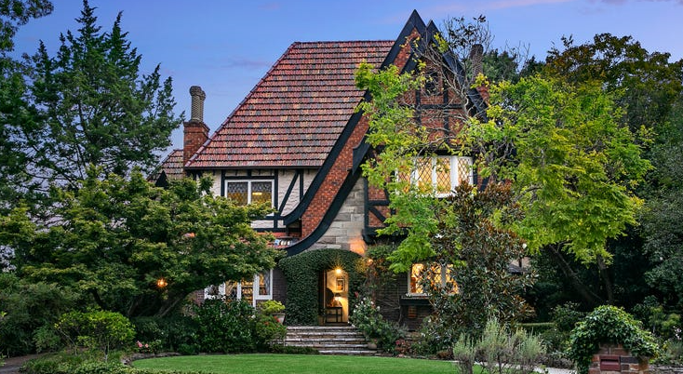

Lot 5 DP 9207

**Hornsby Shire Council details**

**Heritage Register: Item No. 297**

The land was sold to Aubrey William Lofts, a railway engineer, in 1925, who built a small brick two-bedroom cottage on the land in 1926. He had a shed on the property in which he built model locomotives.

Sands Directories 1930-32/33 G. Barwick

Electoral Roll 1933: Garfield Barwick No. 94

In 1929 the property was purchased by the recently married Garfield and Norma Garwick.

*[Garfield Edward John Barwick married Norma Mountier Symons in 1929, district of Burwood]*

They called the house “*Mundroola”* which was an Aboriginal word meaning ‘only two.’

**Garfield Barwick**

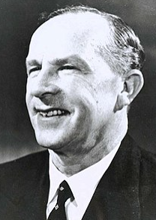

**Sir Garfield Edward John Barwick**, AK GCMG QC was an Australian judge who was the seventh and longest serving Chief Justice of Australia, in office from 1964 to 1981. He had earlier been a Liberal Party politician, serving as a minister in the Menzies government from 1958 to 1964.

In 1937 Garfield Barwick had become sufficiently established to commence making significant alterations to the home. The new house was built on the old foundations and the jarrah floor boards were retained but little else remained. These alterations were done ‘following the ‘Old English’ style of domestic architecture. The house is described as ‘Tudor Revival.’

The newly built house was designed by Charles Bohringer. Bohringer (1891-1962) had been born and trained as an architect in Switzerland, arriving in Australia in 1914, where he established a reputation as a designer of cinemas. The builder of the house was Rupert Symons who was Norma’s uncle.

**1940 Holmlea Estate Cheltenham Auction Sale showing property of G. Barwick.**

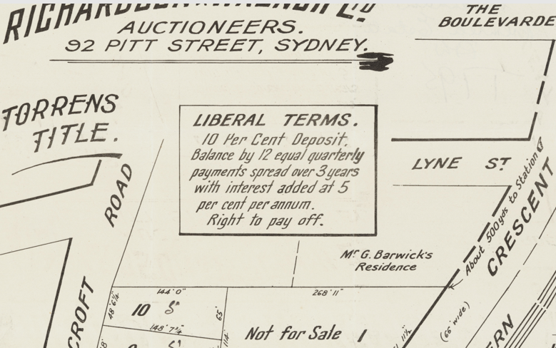

In 1954 the house was put up for sale, described as follows:  
CHELTENHAM

UNDER INSTRUCTIONS FROM Sir Garfield Barwick, Q.C.

A CHARMING TWO-STOREY TUDOR-STYLE RESIDENCE - VAC. POSSESSION

"MUNDROOLA." 94 THE CRESCENT.

This LOVELY and MOST ATTRACTIVE two-storey Texture and Face Brick RESIDENCE stands In a BEAUTIFUL GARDEN SETTING and overlooks a PLEASANT BUSHLAND SETTING.

The whole ATMOSPHERE of "MUNDROOLA" is one of SHEER DELIGHT and the QUIET ENGLISH ATMOSPHERE is one which will APPEAL to many BUYERS.**1**

By 1958 the Barwicks were living at 37 Mahers-road, Beecroft, also named “Mundroola.”

In 1968 Diane Barwick, daughter of Garfield and Norma, was married.

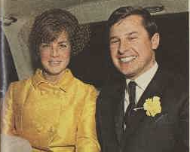

ABOVE: Newlyweds Mr. and Mrs. William Robbins leaving the Congregational Church, Cheltenham, following their marriage. The bride was formerly Miss Diane Barwick, daughter of Sir Garfield and Lady Barwick, who received guests at a reception at their home, "Mundroola," Beecroft. The bride-groom is the younger son of Mr. and Mrs. Thomas Robbins, of Newport.

The house was last sold in 2019, by then named “Ashby”.2

**Bibliography:**

1 Sydney Morning Herald, 16th October 1954

2 [94 The Crescent, Cheltenham, NSW 2119 - Property Details (realestate.com.au)](https://www.realestate.com.au/sold/property-house-nsw-cheltenham-130771930)

**Resources available (varies):**

* Sands Directories 1858-1933 City of Sydney [Sands Postal Directory | City of Sydney Archives (nsw.gov.au)](https://archives.cityofsydney.nsw.gov.au/nodes/view/495003)
* Newspaper articles – TROVE - [Search - Trove (nla.gov.au)](https://trove.nla.gov.au/search/advanced/category/newspapers)
* Ancestry.com (subscription only) [Genealogy, Family Trees and Family History Records online - Ancestry.com](https://www.ancestry.com.au/) – Sands Directories, Electoral Rolls, Family photos (Public Member photos), Census lists, marriage details, + miscellaneous
* N.S.W. Births, Deaths & Marriages [Family history search | NSW Government](https://www.nsw.gov.au/family-and-relationships/family-history-search) (QLD & Victoria also obtainable online)
* House photos and information via Hornsby Shire Council website for Property Search and Heritage Register [Heritage | Hornsby Shire Council (nsw.gov.au)](https://www.hornsby.nsw.gov.au/property/build/heritage)
* House photos and associated information via Internet search on address via Real Estate websites (from 2005)
* “Beecroft and Cheltenham Heritage Walks” - Beecroft-Cheltenham History Group Inc. 2004 book (1st edition)
* Australian War Museum website [Home | Australian War Memorial (awm.gov.au)](https://www.awm.gov.au/)
* Beecroft and Cheltenham History Group website [Beecroft and Cheltenham History - Beecroft Cheltenham History Group (bchg.org.au)](https://bchg.org.au/)