**98 THE CRESCENT, CHELTENHAM (“Holmlea”)**

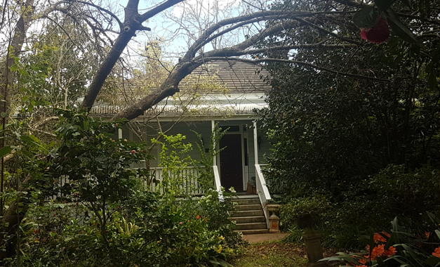

Lot 12 DP 534976

**Hornsby Shire Council details**

**Heritage Register: (NONE)**

*Holmlea* is a timber cottage, possibly built in the late 1890’s, with a wrap-around veranda. it has sidelights at the front door.

In 1909 the Lea family lived in this cottage with a wrap-around veranda. That year Noel Lea won a gold medal for general proficiency at Miss Long’s school and kindergarten, Beecroft.

In 1910 ‘Harry’ Lea, employed as a fitter at the Eveleigh Railway Workshops was killed when struck by the buffer of an outward-bound Homebush train while crossing the line near Redfern station to get his train home. ‘Lea lived at “Holmleigh,” [sic] Beecroft-road, Cheltenham.’ He was aged 39 years.

Deceased left a widow (May) and family of five children, the eldest son being Noel.

[*Henry Arkell Lea married May Caroline Hallett in 1894, Sydney]*

Sands Directories 1915-1932/33 Mrs. May C. Lea “Holmlea”

Sands Directories 1921-23 Mrs. H. M. Lea

Electoral Roll 1933: May Lea “Holmlea”

In October 1917 Private Harry Noel (‘Noel’) Lea, 17th Batt., A.I.F., was killed in action on the Western Front, at Passchendaele, Ypres, Belgium, aged 21 years 10 months. Apart from his family, he also left a grieving fiancé, Miss H. M. Gilbert. Before the war he worked in the Bank of New South Wales (now Westpac) where he had started in 1911. His name is on the Beecroft War Memorial.

The 1933 Electoral Roll lists May Caroline Lea (home duties), Eric Lea (engineer), Edna May Lea and Alan Lea (clerk) at “Holmlea,” Beecroft-road, Cheltenham

In 1936 Alan Lea, working at the Bank of N.S.W., Eastwood, married Irene Agnes Redshaw, of Stanmore, formerly of Eastwood.

In 1940 the property was subdivided and put up for sale, described as follows:

HOLMLEA ESTATE, comprising A CHOICE SUBDIVISION of NINE RESIDENTIAL SITES, fronting CHELTENHAM CRESCENT and OLD BEECROFT ROAD.

Elevated Allotments, commanding a wide picturesque rural outlook.

Convenient to station. Water, gas, and electricity available.1

**Holmlea Estate – Cheltenham Subdivision 1940**

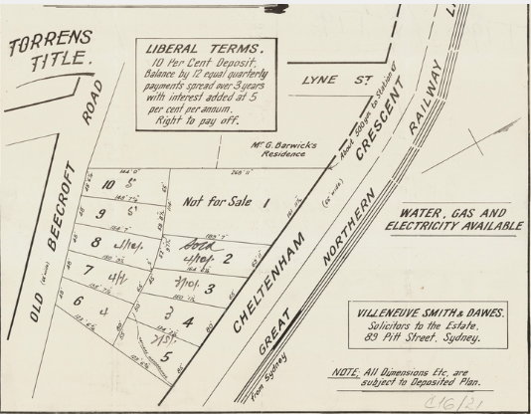

In 1943 May Caroline Lea (home duties), Eric Lea (fitter) and Edna May Lea were still living in the cottage “Holmlea.”

In 1944, at her residence, “Holmlea,” May Caroline Lea died, mother of Noel (deceased), Eric, Alan, Edna, and Joyce. She was privately cremated. Her son, Alan, was then a teller at the Springwood branch of the Bank of N.S.W.

In 1954 two members of the Lea family were still living at “Holmlea,” - Eric Lea (engineer), Edna May Lea and Joyce Lea (teacher).

**Bibliography:**

1 Daily Telegraph, 9th November 1940

**Resources available (varies):**

* Sands Directories 1858-1933 City of Sydney [Sands Postal Directory | City of Sydney Archives (nsw.gov.au)](https://archives.cityofsydney.nsw.gov.au/nodes/view/495003)
* Newspaper articles – TROVE - [Search - Trove (nla.gov.au)](https://trove.nla.gov.au/search/advanced/category/newspapers)
* Ancestry.com (subscription only) [Genealogy, Family Trees and Family History Records online - Ancestry.com](https://www.ancestry.com.au/) – Sands Directories, Electoral Rolls, Family photos (Public Member photos), Census lists, marriage details, + miscellaneous
* N.S.W. Births, Deaths & Marriages [Family history search | NSW Government](https://www.nsw.gov.au/family-and-relationships/family-history-search) (QLD & Victoria also obtainable online)
* House photos and information via Hornsby Shire Council website for Property Search and Heritage Register [Heritage | Hornsby Shire Council (nsw.gov.au)](https://www.hornsby.nsw.gov.au/property/build/heritage)
* House photos and associated information via Internet search on address via Real Estate websites (from 2005)
* “Beecroft and Cheltenham Heritage Walks” - Beecroft-Cheltenham History Group Inc. 2004 book (1st edition)
* Australian War Museum website [Home | Australian War Memorial (awm.gov.au)](https://www.awm.gov.au/)
* Beecroft and Cheltenham History Group website [Beecroft and Cheltenham History - Beecroft Cheltenham History Group (bchg.org.au)](https://bchg.org.au/)