**BEECROFT QUARRIES**

**Cumberland Argus and Fruitgrowers Advocate, Sat 18 Apr 1896**

Ryde Police Court.

TUESDAY, APRIL 14. (Before Messrs. F. W. Edwards, P.M.) STEALING.

Robert Williams, of Beecroft, was proceeded against for stealing one pinch bar, the property of the Railway Commissioners, from the Beecroft railway promises on or about the 6th instant.

Constable Russell deposed that on Saturday last he went to the accused's quarry at Beecroft, and ascertained from him that he had seen a man plant the bar in the railway yard on Thursday night. Witness went with Hogan and accused to the yard and found the pinch bar produced. Michael Hogan, officer in charge at Beecroft station, corroborated.

**Cumberland Free Press, Sat 18 Apr 1896**

Ryde Police Court.

(Before Mr. F. W. Edwards, P.M.)

Robert Williams was placed in the dock charged with having stolen a pinch-bar, valued at 5s, the property of the Railway Commissioners, from the Beecroft Railway Station, on or about the 6th of April.

Constable Wm. Russell, of Ryde, deposed to having proceeded to the quarry owned by the defendant, where he arrested him and charged him with the theft. This was on the 11th inst. He said all the tools in the quarry were his. Witness asked him how many bars he had, and he said he had three, adding that he supposed the constable was after the bar that Hogan said was stolen from the railway by him. He had not the bar; and the thing was a put-up job. He subsequently, on the way to the Ryde police station, stated that he knew where it was planted in railway yard. Acting on the prisoner’s advice he looked for and found it stowed away near the W.C.

Michael Hogan, officer in charge of the Beecroft Railway Station, gave evidence as to missing the bar, and Identified that produced in Court as the one stolen.

The prosecutor proceeded to cross-examine the witness in a thoroughly professional style, and, having exhaustively and somewhat tediously accomplished the task, observed, pompously, “That is all I have to ask you.”

William Willworth deposed that he had been in the employ of the accused; the bar in question had been in the defendant's quarry. It was the only one of the kind there. He (witness) had used it.

The defendant called Constable Denmann, of Hornsby, as a witness.

The Constable, examined by the prosecutor, deposed that witness told him (constable) that

he thought the bar was buried by someone else under a heap of stones in his (defendant's) quarry. Prosecutor said that if the bar was found when the quarry was cleaned out, he would restore it. He (Constable) had very great difficulty in getting any information, whatever from the prosecutor about the bar.

Defendant examined the witness, and so lengthy was the process that the P.M. declared that the time of the Court was being wasted. The prisoner, however, was of no such opinion and seemed determined to have his own way, with the result that he was precipitately removed to the dock, which he had been allowed to evacuate *pro tem*.

Defendant was fined 40s and 5s costs; or, in default, seven days' gaol.

**Cumberland Argus and Fruitgrowers Advocate, Sat 10 Sep 1904**

Beecroft.

SCHOOL OF ARTS. — An event of considerable importance to Beecroft will take place shortly, viz., the laying of the foundation stone of the School of Arts. The ceremony is to be performed by Miss Tucker, daughter of Mr. C. C. Tucker. The foundation stone is being quarried in the district — from a freestone quarry discovered by Mr. G. H. Willis on his land fronting Mary-street. The steps of the building will be made of the same material.

**Newcastle Morning Herald and Miners' Advocate (NSW: 1876 - 1954), Friday 14 February 1947, page 6**

GELIGNITE STOLEN FROM QUARRY MAGAZINE

SYDNEY, Thursday. - Thieves broke open an explosives magazine at Beecroft last night and stole three cartons of gelignite. The magazine was near a stone quarry, the property of E. G. Martin Pty. Ltd, Murray Farm-road. Detectives from Ryde, accompanied by experts from the C.I.B., to-day examined the magazine for fingerprints. They are continuing investigations.

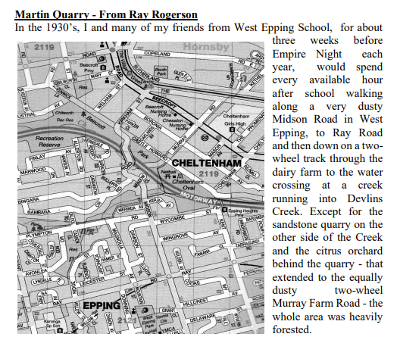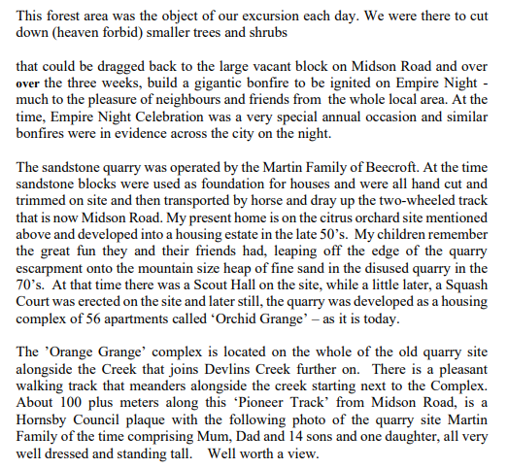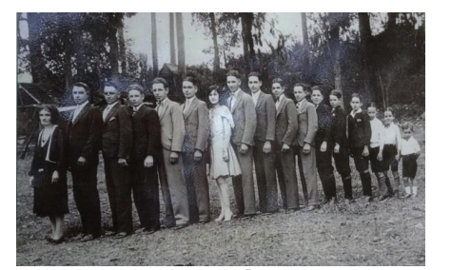

**[Probitas July 2020]**