**Beecroft Methodist Church 1915**

**Cumberland Argus and Fruitgrowers Advocate (Parramatta, NSW: 1888 - 1950), Saturday 8 August 1914, page 7**

TO BUILDERS.

TENDERS will be received, by the undersigned until noon of MONDAY, August 17, for the ERECTION of a NEW METHODIST CHURCH, at BEECROFT. Plans, etc., may be obtained at my office.

ALFRED G. NEWMAN,

Architect, 82 Pitt Street, Sydney.

**Sydney Morning Herald (NSW: 1842 - 1954), Tuesday 3 November 1914, page 4**

TENDERS.

Beecroft - Erection of a new Methodist Church and also separate tender for the removal of the existing weatherboard church to a new position on the site.

Mr Alfred G Newman, architect, 82 Pitt-street

**Cumberland Argus and Fruitgrowers Advocate (Parramatta, NSW: 1888 - 1950), Saturday 14 August 1915, page 1**

The foundation stone of the proposed Methodist Church for Beecroft is to be laid on the 21st instant, by Mrs. F. Mason.

**Sydney Morning Herald (NSW: 1842 - 1954), Saturday 28 August 1915, page 8**

SYDNEY DIOCESAN SYNOD.

On Saturday last Mrs. F. Mason laid the foundation-stone of a new Methodist church

at Beecroft. The new building, which is to take the place of the old church which has done service for 20 years, is to cost over £1000.

**Methodist (Sydney, NSW: 1892 - 1954), Saturday 28 August 1915, page 10**

NEW CHURCH FOR BEECROFT

RYDE CIRCUIT.

The modest little church which has accommodated the Methodist congregation for nearly 20 years is soon to be supplanted by an ornate brick structure. The foundation stone was laid on Saturday 21st August, under the most favourable conditions. There was a large and

representative gathering present, including Revs. T. B. Holmes, Chairman of the District, J. G. Morris Taylor, E. E. Crosby, B.A., B. Lane, H. E. Andrews, E. Masterman, R. H. Doust, Bostock Jones, B. Deane, C. Wheeler, J. Young (Anglican), and A. M. Ogilvie (Presbyterian). Rev. B. Lane occupied the chair. The proceedings opened with the National Anthem. Rev. E. E. Crosby offered prayer, then followed the hymn, “The Church's one foundation,” led by the choir. Rev. R. H. Doust read the Scripture portion. The Rev. T. B. Holmes delivered a stirring address on higher patriotism of work and service for the Church of God. Mr. G. W. Pettit, hon sec. for the building committee, presented a brief financial statement disclosing the sum of £570 already in hand, the contract price for the new church being £1050, exclusive of furnishings. The Rev. B. Lane at this stage, asked Mrs. Frederick Mason to set the stone, and presented her with a handsome silver trowel, suitably inscribed. Mrs. Mason acknowledged the gift, and declared the stone well and truly laid in the name of the Father, Son, and Holy Ghost. Many tributes were paid to Mr. and Mrs. Mason for early pioneer work on behalf of the cause at Beecroft, and for their liberal support during the past quarter of a century. Upon the invitation for a liberal collection, Mr. Mason was the first to respond, with a cheque for £50. The total amount taken up was £83, and including a cheque for £21 from Mrs. C. T. Newman, of Strathfield, the total proceeds amounted to £104. After the hymn, “O Lord of Hosts,” were given in the most cordial and brotherly manner by Revs. J. Young, Anglican, and A. M. Ogilvie, Presbyterian, Rev. J. G. Morris Taylor added an interesting address, largely reminiscent. The doxology and benediction brought the proceedings to a close. The Ladies' Church Aid dispensed afternoon tea, which was much appreciated and brought forth thanks in the form of three hearty cheers.

The architect for the building is Mr. A. G. Newman.

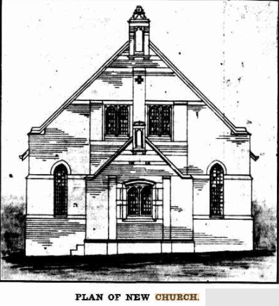

**Methodist (Sydney, NSW: 1892 - 1954), Saturday 20 November 1915, page 7**

The opening of the new church at Beecroft is to take place this afternoon (Saturday), and will be further continued on Sunday, when special services will be held at 11 a.m. and 7 p.m. Visitors and. friends will receive a hearty welcome from the Beecroft folk, whose enterprise should be encouraged. For full particulars see advt. on page 6 of this issue.

BRIEF MENTION

The opening of the new church at Beecroft was successfully celebrated on Saturday last. The President preached to a full church, and the service was greatly enjoyed. On Sunday the preachers were the Revs. C. J. Prescott, M.A., and Rev. W. E. Bennett, M.A. There were good congregations at all the services.

**Methodist (Sydney, NSW: 1892 - 1954), Saturday 20 November 1915, page 6**

Beecroft Methodist Church.

Opening of the new Church,

SATURDAY, NOVEMBER 20, 1915,

at 3.30 p.m.

The opening ceremony will be performed by Mr. George W. Pettit, Secretary of the Church Trust.

The Dedicatory Service will be conducted by the President of the Conference, Rev. Joseph Woodhouse.

Train leaves Sydney 2.38, Hornsby 3.5, Beecroft for Sydney 5.19, for Hornsby, 5.26.

SPECIAL SERVICES,

SUNDAY, NOVEMBER 21.

11 a.m. Rev. W. E. BENNETT, M.A.

7.30 p.m. Rev. C. J. PRESCOTT, M.A.

PUBLIC MEETING,

MONDAY, NOVEMBER 22.

Chairman: Rev. BENJAMIN LANE

Speaker: Rev. J. E. CARRUTHERS, D.D.

Friends and Visitors very cordially invited.

**Sydney Morning Herald (NSW: 1842 - 1954), Saturday 29 July 1922, page 7**

A kindergarten hall is to be built in connection with the Presbyterian Church at Beecroft.

**Methodist (Sydney, NSW: 1892 - 1954), Saturday 27 November 1915, page 7**

**Construction and Local Government Journal (Sydney, NSW: 1913 - 1930), Wednesday 30 June 1926, page 18**

Architect A. Lanyon Clark has prepared designs for a new Methodist School Hall and kindergarten, at Beecroft (N.S.W.), and has accepted the tender of E. T. Ohlsson for its construction.

**Methodist (Sydney, NSW : 1892 - 1954), Saturday 4 September 1926, page 12**

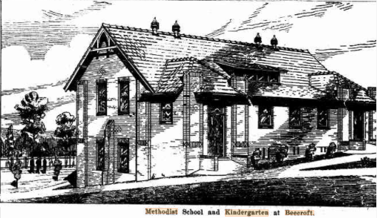

**Methodist (Sydney, NSW: 1892 - 1954), Saturday 5 February 1927, page 13**

CIRCUIT NOTES.

EPPING — Quarterly Meeting. Held at Epping on the 12th January.

… and Beecroft is expecting big things with the new school hall recently opened.

**Sydney Morning Herald (NSW: 1842 - 1954), Wednesday 13 April 1927, page 13**

KINDERGARTEN HALL AT BEECROFT.

Recently erected by the Methodist Church.

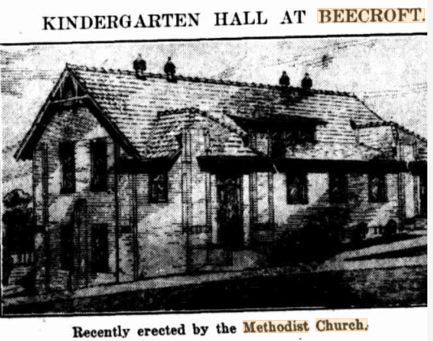

**Sydney Morning Herald (NSW: 1842 - 1954), Wednesday 13 April 1927, page 13**

KINDERGARTEN HALL AT BEECROFT.

The Methodist Kindergarten Hall recently erected at Beecroft, and which is illustrated in this issue, forms portion of a very complete block of church buildings in that district. The position of the kindergarten hall is immediately at the rear of the church. The accommodation provided includes a large assembly hall, with roomy classrooms Along one side and at one end are large classrooms, one of the latter being fitted for social purposes as a kitchen. Owing to the fall in the grade of the land, opportunity was taken to elect a very fine kindergarten hall, with all the necessary provisions to carry on this class of teaching. The question of ventilation had careful consideration, and the building is well lighted. Large folding doors divide the main hall from the classrooms, and enable the whole area to be converted into one large assembly room. The architect was Mr. A. Lanyon Clark, and the builder Mr. E. T. Ohlsson, of Ryde.

**The Methodist (Sydney, NSW: 1892 - 1954), Saturday 10 December 1927, page 7**

BEECROFT.

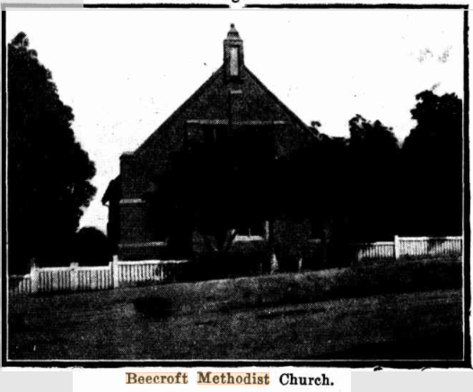

Among the many charming suburbs of Sydney, Beecroft, though apparently not generally well-known, deserves a prominent position. This residential suburb is favourably situated in a rural district on the northern railway line, and while much of its natural beauty has been retained, it has been enriched by beautiful homes and gardens. Having an altitude of 450 feet, it enjoys a salubrious climate, and also has the advantages of easy access to the city, and an uncrowded settlement. Methodism is worthily represented in this attractive place. Though its numbers are not large, it has grown steadily, and its growth has corresponded with the progress of the locality. Services were commenced in 1890 in a private house, and the first church was erected in 1895, when the district was part of the extensive Ryde circuit. This building was replaced by a new church in 1915, and the old structure was removed to the rear and utilised for a school hall, until it was superseded by a new one, which was opened towards the close of last year. The new building is commodious, and in addition to the main hall, there are class rooms opening off it, facilities for social requirements, and also a kindergarten room. The church and hall are beautiful buildings, soundly constructed, and well appointed, and there is now accommodation which is likely to meet the needs of the congregation and the children of the Sunday school for a considerable time.

The property is estimated to be worth £4,000, and there is a debt of only £662 owing upon it. When it is considered that the whole of the money which has created this valuable asset (apart from the land) has been contributed within 15 years by a congregation that is comparatively small, it must be realised that generous support has been given. In this connection mention must be made of the splendid assistance of the Ladies' Church Aid Society, which in the last five years has raised a sum of £605.

The church is fortunate in having willing workers who take a special interest in attending to the upkeep of the property. The grounds have been made into a garden, and this and the interior of the buildings are kept in excellent condition. The place, therefore, both inside and outside the buildings, has a neat and attractive appearance.

The services of the church are marked by a feeling of reverence and devoutness, and this in no small measure is attributable to the orderliness of the service, the beautiful floral decorations, the tasteful playing of the organist, and the expressive singing.

The anniversary services recently held were impressive and inspiring. The preachers were Dr. Prescott and Rev. Victor Bell, and at the public meeting Mr. R. Venning Thomas was the speaker, the chairman being the superintendent minister, Rev. Wallace Deane. There were large and appreciative congregations at each service. The report of the secretary, Mr. A. W. Smith, referred to the appointment for the first time of a second minister to the circuit, who will reside at Beecroft, and showed that the various activities of the church had been well maintained throughout the year. The financial statement made by the treasurer, Mr. J. A. Somerville, was satisfactory. This year it has been resolved to substitute the method of direct giving for the usual annual fair, and there is reason to believe that the result will be equally favourable. The singing of the choir was again a special feature of the services. With the assistance of friends in the solos and choral work, they presented a fine programme of music, which included Mendelssohn 's ''Hear my prayer,” and under the careful direction of Mr. G. W. Pettit, with Mr. Milton Smith as an efficient organist, a high standard of singing was maintained.

**Construction and Real Estate Journal (Sydney, NSW: 1930 - 1938), Wednesday 2 February 1938, page 16**

Architects Wm. R. Laurie and Eric F. Heath are calling tenders for the erection of a kindergarten school at Beecroft, and for the erection oi a large residence at Rose Bay.

**Sydney Morning Herald (NSW: 1842 - 1954), Tuesday 10 May 1938, page 7**

CONTRACTS LET.

C. Ede for a kindergarten school at Beecroft and a residence at Killara.

**Methodist (Sydney, NSW: 1892 - 1954), Saturday 30 June 1951, page 10**

THE BEECROFT METHODIST MOTHERS' CLUB

This club was formed in 1946 by Mrs. Barrett, wife of the Rev. S. M. Barrett. It started out as a Kindergarten Mothers' Club, and so consisted of the younger mothers of the congregation. Our first undertaking was to brighten up the Kindergarten room. With the help of the

fathrs, walls and ceilings were painted, chairs and tables repainted in pastel colours, bright curtains added, and Kindergarten equipment such as blocks, books, clay, scissors, etc., were purchased, and since then a sum of money is made available to replenish the stock monthly. Now that the Kindergarten has been satisfactorily equipped we have offered to help the whole Sunday School in anything they see fit to call upon us to do, and so have dropped the word “Kindergarten” from our official title.

We have two main functions a year: A birthday party and a Christmas tree. At the former the capacity of the hall is stretched to its utmost, and entertainment and supper are provided by the mothers.

The latter is the usual Christmas tree party for our small folk. At our monthly meetings we have had such diverse topics as floral art, cake decoration, glove-making, hat renovation, and — to get a little ready money — recipe nights, and “bring-and-buy” nights. To these meetings we also bring current magazines and flowers which are taken to two wards, one men's and one women's, we have “adopted” at Yaralla. At Christmas we send extra flowers, also individual pots of home-made jam and other nick-nacks for the inmates.