**Volcanic Dykes around Beecroft**

**Book – The Geology of Sydney and the Blue Mountains**

**By Rev. J. Milne Curran**

**Published 1899**

P260 – Good examples of dykes of decomposed basalt are known to occur – near Beecroft Railway Station, crossing the line

P324 – A railway cutting exposes a decomposing basaltic dyke at Beecroft (Fig. 11 – Basaltic Dyke through Wianamatta Shales, near Beecroft Railway Station).

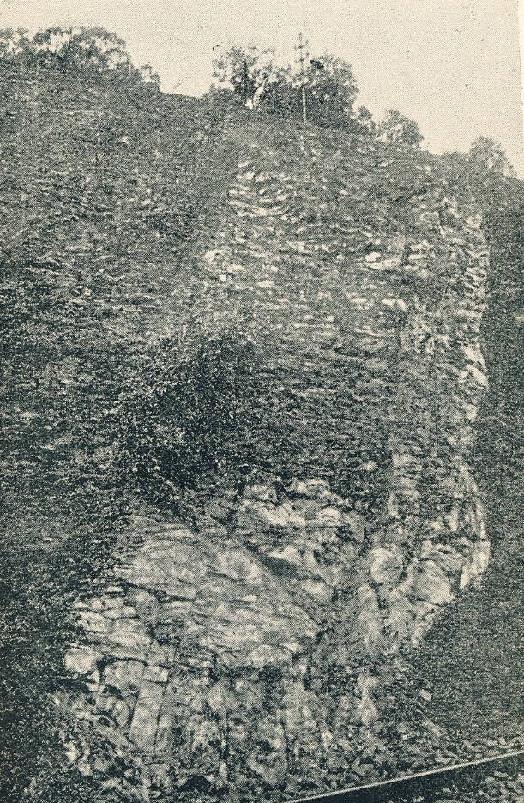

**Cumberland Argus and Fruitgrowers Advocate, Wednesday 16 Nov 1898**

Publications Received.

“Geology of Sydney and the Blue Mountains,” by the Rev. J. Milne Curran', F.G.S., is to hand from Messrs Angus and Robertson, and as the author says in his preface, supplies a “long felt want.” We know too little of the geology of Australia. A visitor to the mountains, for instance, simply feels stupid when gazing, in a blind sort of way, at the marvellous scenery, wondering what could have caused such mighty chasms and inundations. He says at once earthquake and eruptions. No other power, he considers, could have rent the land in such violent fashion. … … … explanation of all these things, makes the way of the tourist so easy, and intelligible, that the very stones and rocks speak to him as he toils through the gorges and scales the precipitous heights of the mountains. What a pleasure these, excursions must be to the botanist and geologist— to be able to recognise every stone and growth — in contradistinctions to the man who walks along blindfolded and doesn't know a rock or plant by its name. How additionally charming is the grandeur of our mountain scenery when we learn, on the authority of our geologists, that it contains evidences everywhere of once having been submerged by a vast sea.

We have now some fair idea of what havoc has been made of the upheaval plateau in its old age. We have traced its chequered history through long cycles of change, once the bed of an ancient sea, then dry land, covered with a rich vegetation, of which not a species has survived, and again depressed beneath the waters. All the time fresh layers were being added to the load, that was, from its sheer weight, sinking into the earth's crust. Then the pent-up energy left in the globe comes into play, and the sediments are lifted high above the sea, and at once the work of destruction begins. The separate hills were once a solid mass. But, nature, sets to work her ‘agents of denudation' and we have left peaks, crags and cliffs, wrecks of the great plateau that was.

And, further on, the mystery is still more elucidated”

It is surely most reasonable to explain the past by appealing to causes now in operation. It, is equally unreasonable to call in the. aid of catastrophes and exceptional conditions to explain what may have attributed to causes still in operation around us and with which we are familiar. The enormous ravines of the Blue Mountains are not the direct work of earthquakes, earth movements, or cataclysm, but the result of running water. The book is full of deeply interesting matter and so presented that it can be readily grasped by the idlest thinker. We regret, however, the absence of reference to the marvellous formations of the Kanangra Walls, beside which we think the Wentworth Falls shrink into insignificance. It is a pity, too, that the reader did not check the spelling of some of the names. McEwan's Creek at Jenolan should not be spelt McKeown. Lowther, on the way down to the caves should not be spelt with a” u.” There are many local references in the book to Pennant Hills' Quarry, Prospect, Rookwood, Beecroft, Ryde, etc., all throwing light on the geological history of this district. The book can be had at The Argus office.

**Daily Telegraph (Sydney, NSW), Sat 4 Dec 1926**

Volcanic Action Near Sydney

Cones, craters, and lava flows, which once existed hundreds or thousands of feet above the present surface, have been swept away without leaving a vestige. The "funnel" of such a volcano, however, is a structure of great permanence. Continuing downwards for miles through the crust of the earth, and filled with materials brought from below by the eruptive forces, highly specialised in character, and totally foreign, in a geological sense, to their immediate environment, such "volcanic necks" are indestructible records of prehistoric volcanic action. One such "neck" occurs about midway between Eastwood and Dundas. As It was filled with basaltic material, it was extensively worked, for many years, as a source of "blue metal", for road construction. In a city so singularly devoid of good road-making materials as is Sydney, such deposits as this have considerable value. Most of the rock filling the Dundas "neck" was ordinary basalt, brought from below in a molten condition, and cooled in the throat of the volcano. More or less completely altered fragments of the sediments building up the deeper parts of the earth's crust under Sydney were dragged along by the rising lava. Amongst these are pieces of coal, hardened and altered by the heat to which they were subjected. Even more Interesting to the geologist are fragments of rocks of kinds very, very rare at the surface, but including types which, from theoretical considerations, are believed to constitute a very large proportion of the earth's interior. Another "neck" occurs to the west of the railway station at Hornsby.

VOLCANIC DYKES. Much more numerous that necks within the metropolitan area are structures known to geologists as "volcanic dykes." These represent nearly vertical fissures, amongst the sedimentary rocks, filled with basalt. The dykes are numbered by scores, but in many instances are not conspicuous to the casual observer. The basalt with which they were originally filled is no longer in the familiar form of "blue metal, but has "weathered," to depths of over a hundred feet, into soft, white or yellow clay. In many Instances this is strongly impregnated with rusty compounds of iron.

In very exposed situations the clay has been removed completely, and we are left with curious, deep, narrow clefts, cutting through the sandstone cliffs like gashes from a giant's knife. Two such clefts are very conspicuous features in the landscape in the cliffs between North Bondi and Marrivorrle (see photograph).

Another gash can be seen in the cliffs of Middley Head, a little to the north of George's Beach.

FORMATION OF BAYS. Even when they have lost their Individuality, through being opened out by the weather, such gashes are profoundly important features of the landscape. They form zones of weakness which arc quickly picked out by waves and weather. All the deeper, narrower bays along our coastline, such as Little Bay, Long Bay, Coogee, Little Coogee, etc., owe their origin to the zones of weakness produced in this way. Inland, the dykes become much less conspicuous, and only rarely are they visible without the aid of artificial excavations. Many of them can be seen as nearly vertical bands of light-coloured clay, in the railway cuttings. Such dykes can be seen, for instance, near Dulwich Hill, Canterbury (2), at Belmore station, between Belmore and Lakemba, near North Strathfield (2). One of the largest and most conspicuous dykes in the metropolitan district is between Beecroft and Pennant Hills.